**Portfolio**

**Paper Kraft’s website development:**

**Responsive web design**

**Assessment 2**

Praphat Chungyampin

Student ID: 12084314

COIT 20268 Responsive Web Design (RWD)

(Term 2 – 2018)

This website development provides information to customers who look forward to Paper Kraft's product and visit the shop front.

**Portfolio 2.1**

**CHAPTER: 7 Page Layouts**

**Home Page Mock-up**

Logo

Menu bar

Welcome message display

Subscribe tab

Highlight item and floor plan

Footer

**Home Page Mock-up (responsive design)**

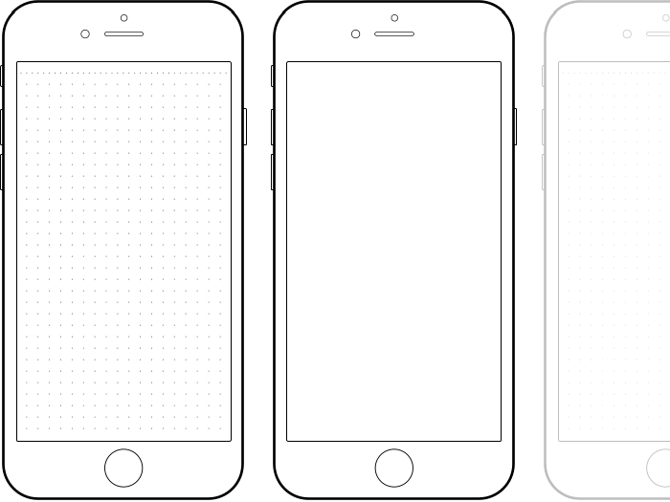

Logo

Hamburger icon

Welcome message display

Subscribe tab

Highlight item and floor plan

Footer

**About Us Mock-up Page**

logo

Menu bar

Text information

Subscribe tab

Footer

**About Us Mock-up Page (responsive design)**



logo

Hamburger icon

Searching icon

Text area

Footer

Text area

**Product category Mock-up Page**

logo

Menu bar

Product category

Subscribe tab

Footer

**Product category Mock-up Page (responsive design)**



logo

Hamburger icon

Subscribe tab

Highlight item and floor plan

Footer

**Product detail Mock-up Page**

logo

Menu bar

Subscribe tab

Footer

Highlight item and floor plan

Sub Product list menu bar

**Product detail Mock-up Page (responsive design)**



logo

Hamburger icon

Subscribe tab

Footer

Sub Product list menu bar

Highlight item and floor plan

**Contact Mock-up Page**

logo

Menu bar

Subscribe tab

Footer

Contact information and map

Form area

Working hour link

**Contact Mock-up Page (responsive deign)**



logo

Hamburger icon

Search tab

Footer

Form area

Contact information and map

Working hour link

**Business working Hour Mock-up Page**

logo

Menu bar

Subscribe tab

Footer

Highlight item and floor plan

**Business working Hour Mock-up Page (responsive deign)**



logo

Hamburger icon

Subscribe tab

Footer

Highlight item and floor plan

**Portfolio 2.2**

**CHAPTER 8: Graphics and Color**

Barker, (2016) explains that the color is important to attract the user when visit the website and allow the user intent longer time to the website. The designer should create the proper color which persuades the customer to understand the theme and concept through their perception as well as remember the characteristic of website.

**Color scheme**

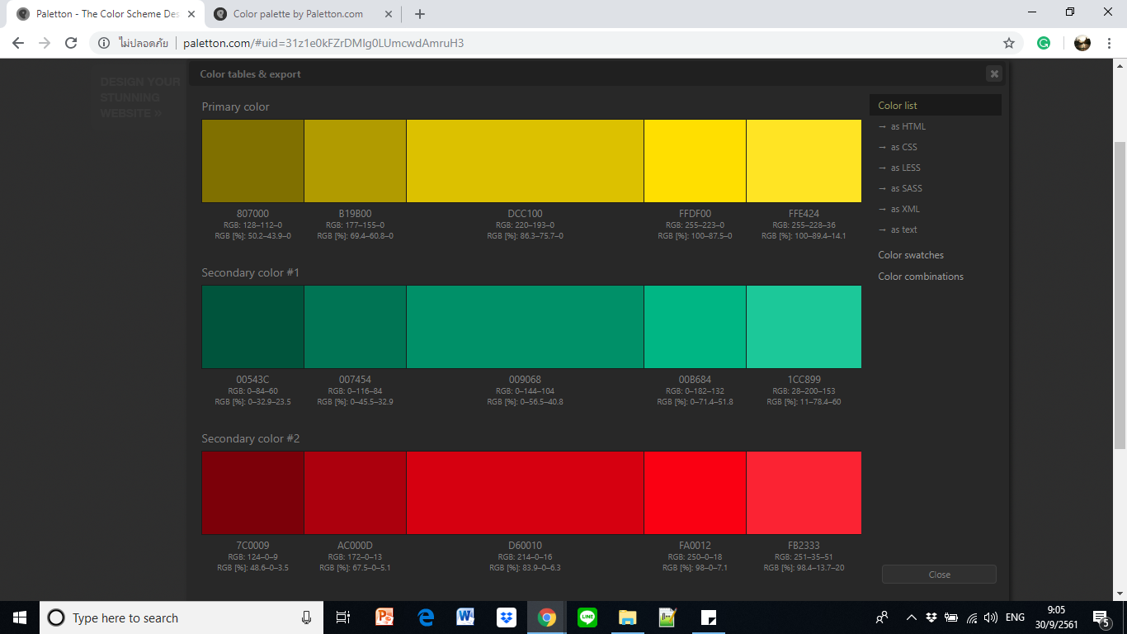 

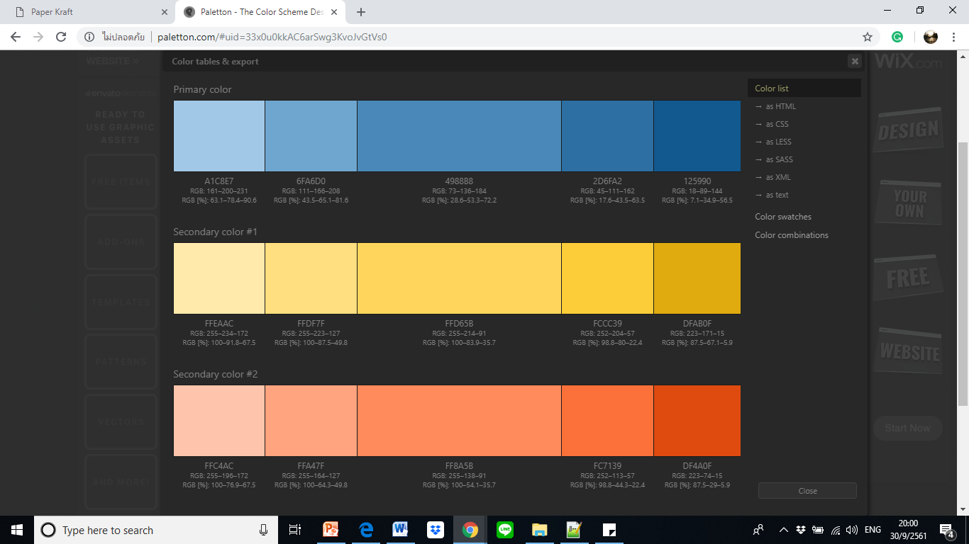

Figure 1: the Primary color (Green) and Secondary colors (Red, Blue) use in website.

Regarding the Paper Kraft’s website, the designer generated the key contrast color theme as mainly with Green color and secondary color as Red and Blue color with various shade and tint for entire website. Besides, the contrast between background-color and font-color is the crucial feature to enhance the legibility which was considered and applied to the website also.

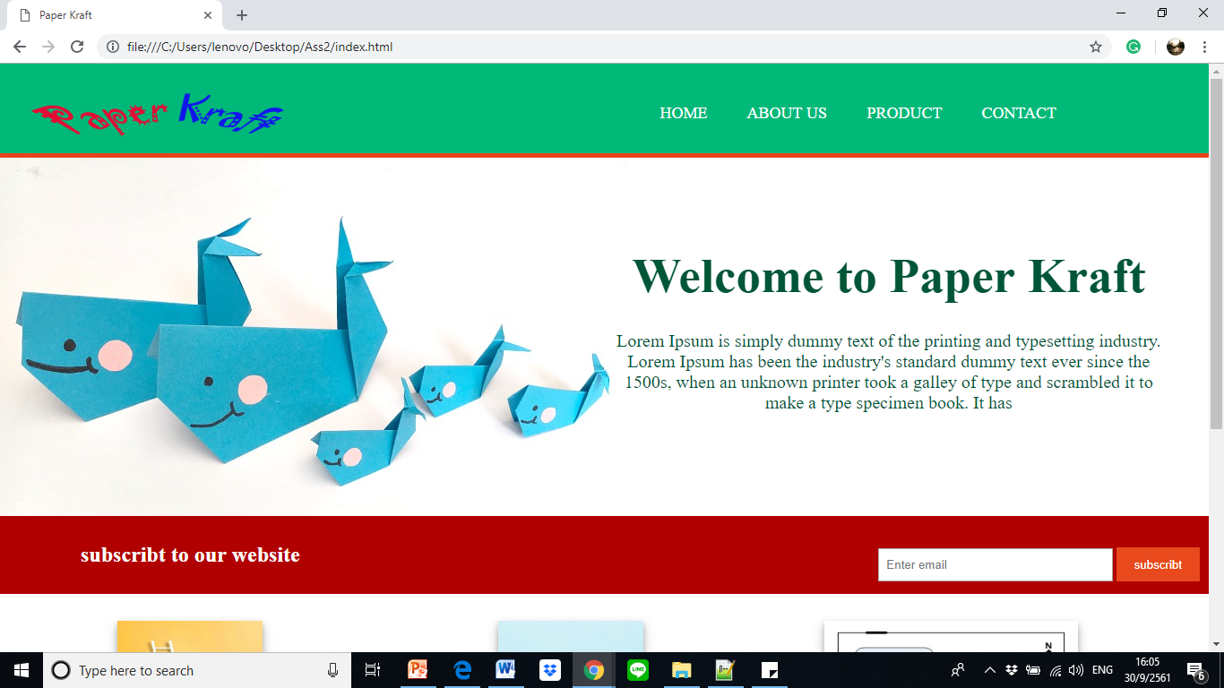

Figure 2: the example of contrast between the font-color, background-color and background-image in website.

**White space around image**

According to the responsive design, the margin property is mentioned to have a space around the image. Likewise, this responsive web design was identified the margin property in term of the percentage value which allows the website to display in various resolution properly.

**The <img> attribute**

It is a tag to describe an image in HTML. This tag requires some part attribute as:

1. ***src*** is the source of image file which is being use to present in area.
2. ***alt*** is the attribute that identify the replacement text for image when it could not be presented. This attribute allows the text show up and make sure the user can understand the information from error image area.
3. ***title*** is the attribute that shows the message providing while hover the image space.

**Standard for all alt and title attributes**

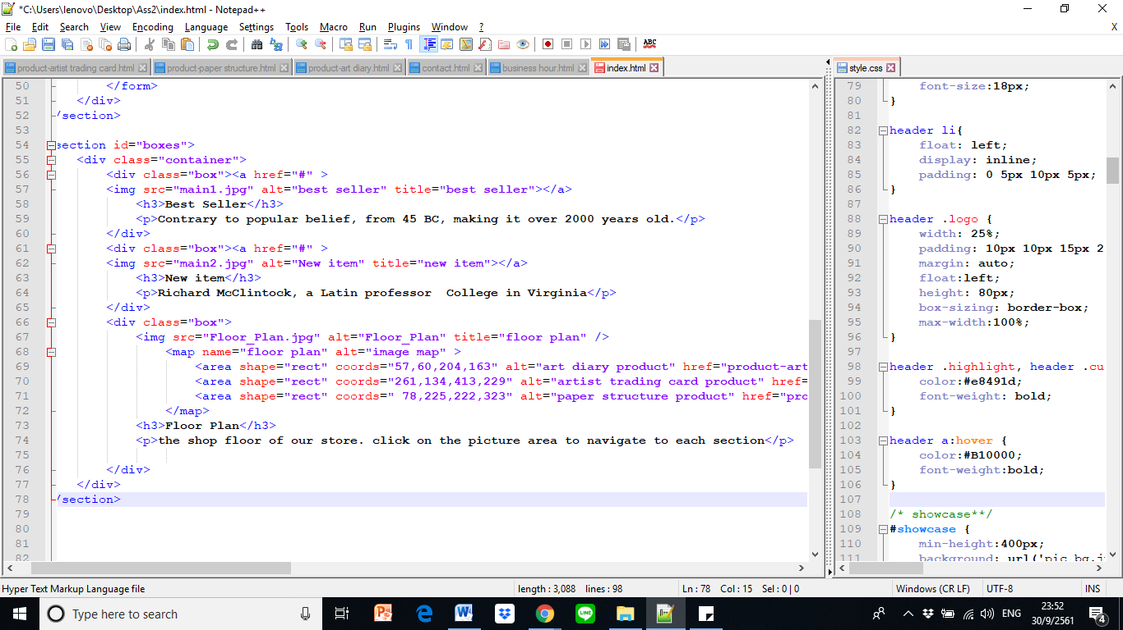

**Color link: Menu bar**

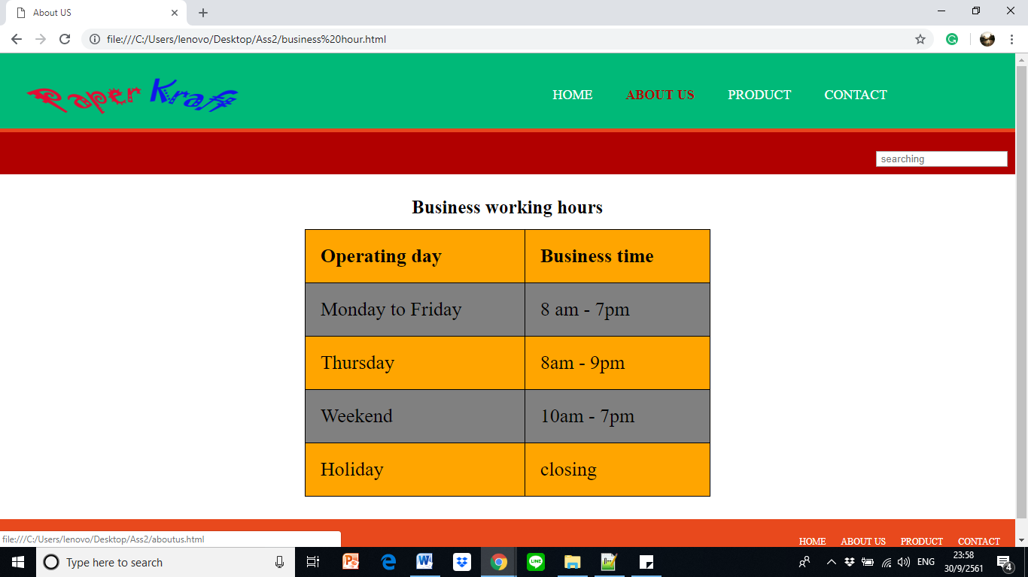

.menu a: hover {#B10000}

.menu a {#ffffff ;}

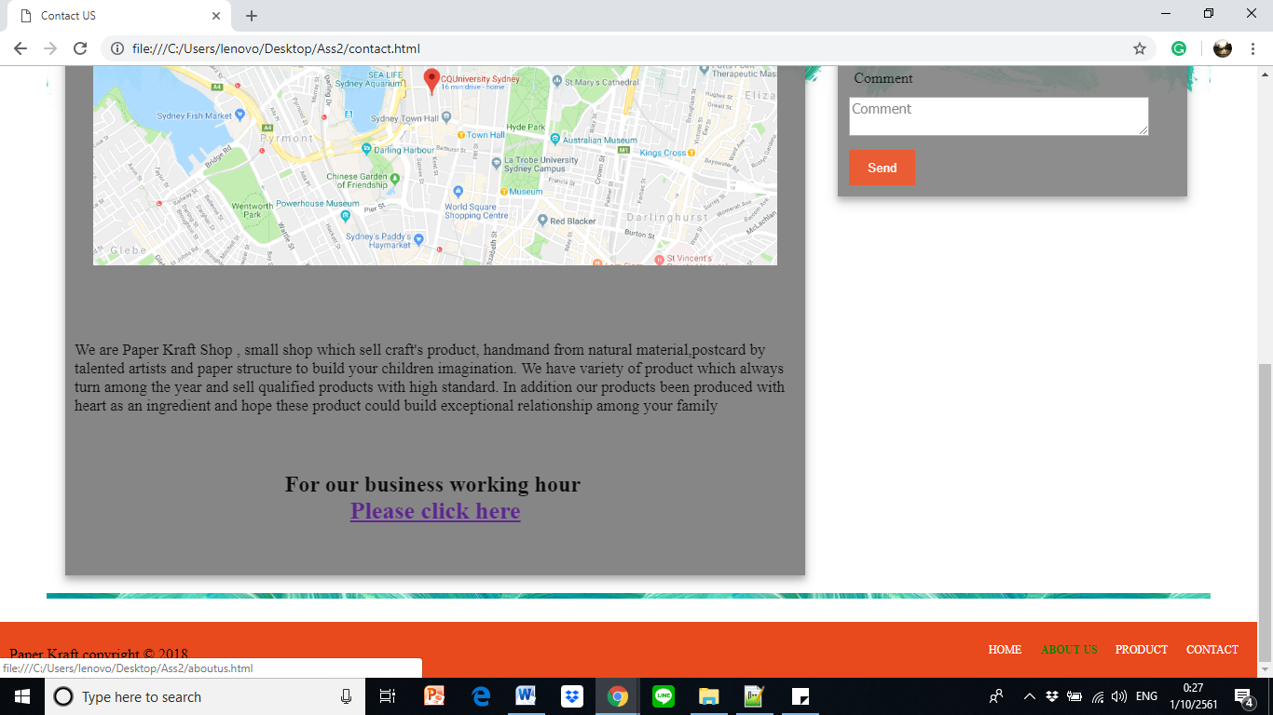**Color link: footer**

footer {#e8491d}

.menu a {#ffffff ;}

**Background-color**

footer {#e8491d}

article#main-col{grey}

#main {url('background1.jpg') }

Header {#00B978}

#newsletter {#B10000}

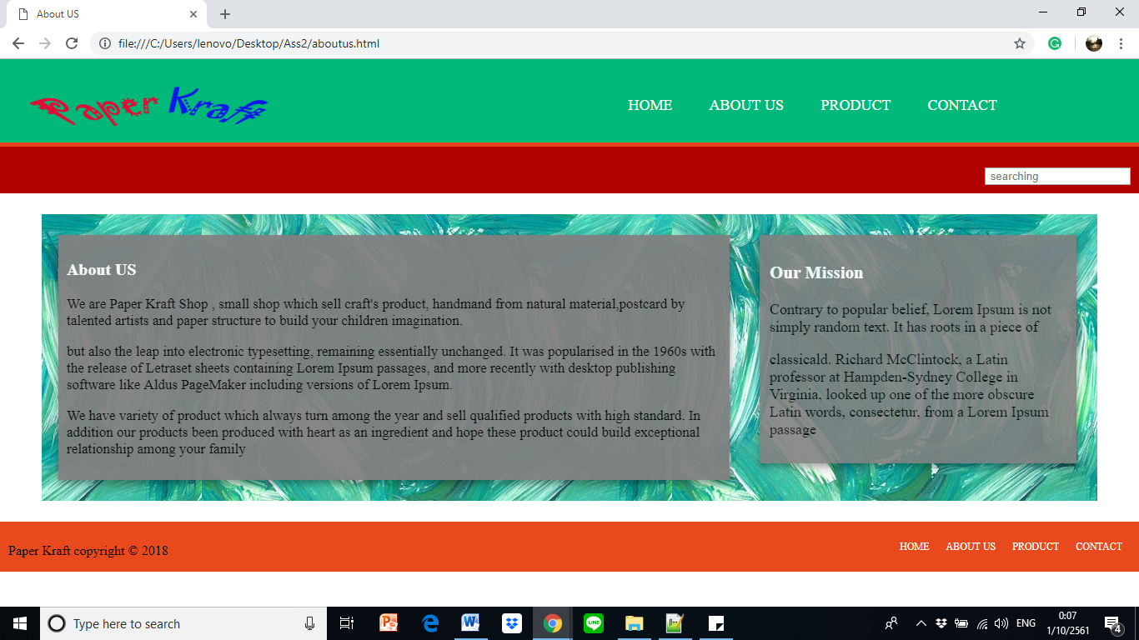

Figure 3: the example of standard color and code using for each area

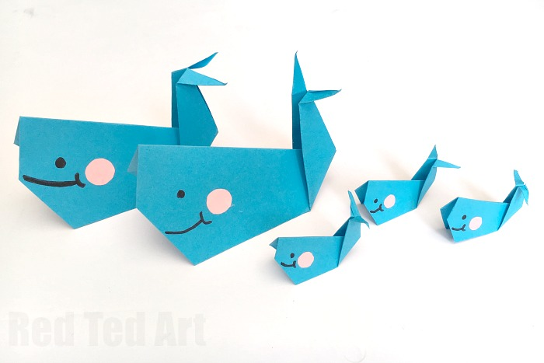

Figure 4: background-image were used in website

(left-homepage, right-about us and contact page)

Likewise, this website contains two background-image applying to the main webpage, as well as the other which is the painting-abstract image which presents in part of About Us and Contact section.

**Standard document**

* p {color : black;}
* <img> include src and alt.
* The color must be legitimate by using contrast color between font and background.
* If screen less than 768px, the hamburger icon will be displayed in every pages.

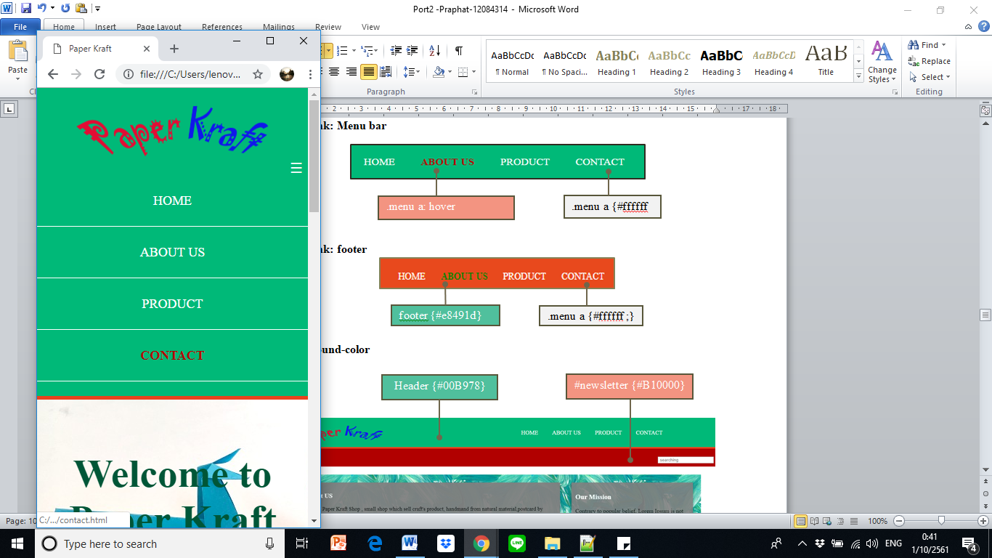

Hamburger icon when screen size less than 768px

Figure 5: hamburger icon (toggle) in mobile device

**Portfolio 2.3**

**CHAPTER 9: Site Navigation**

**Paper Kraft**

**Business hour**

**Artist Trading Card**

**Paper structure**

**Art diary**

**About Us**

**Contact**

**Product**

**Home page**

**Footer**

**About Us**

**Product**

**Home**

**Contact**

**Floor Plan**

**Artist Trading Card**

**Paper structure**

**Art diary**

­­­­

Figure 6: website navigation flowchart

According to the diagram, it shows website navigation flowchart that the homepage would display a welcome message when the user access into the website domain. In addition, the website contains the Menu bar on the top-right which includes four sections area as ***Home, About Us, Product*** and ***Contact****.* As well as at the top-left area would be located by company’s logo.

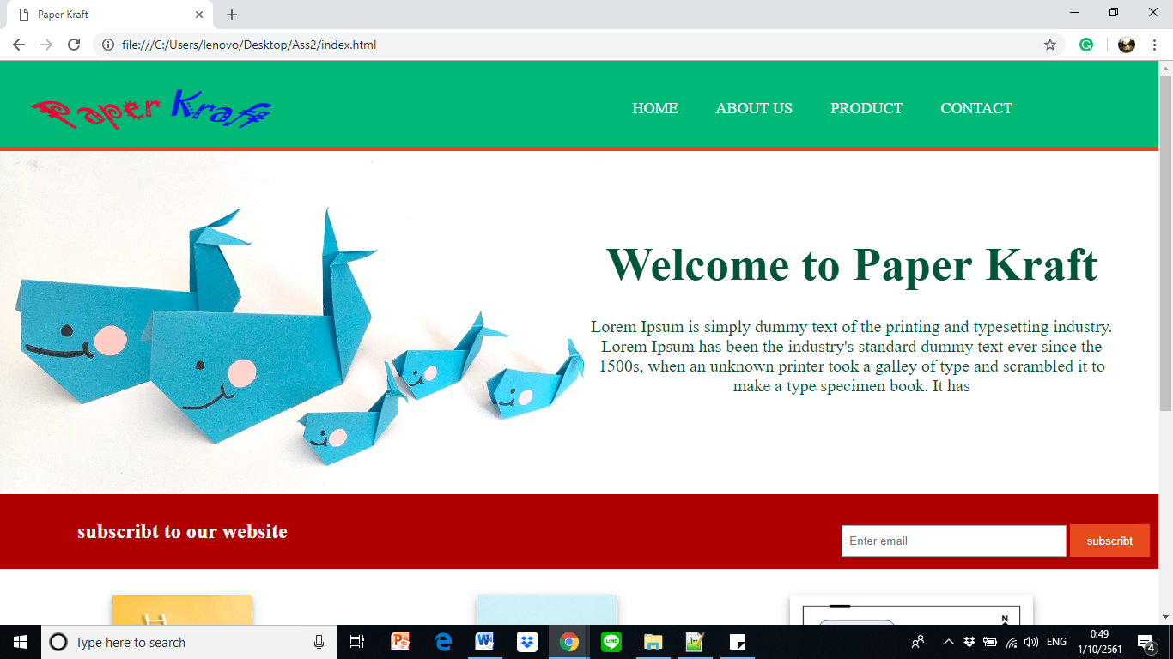

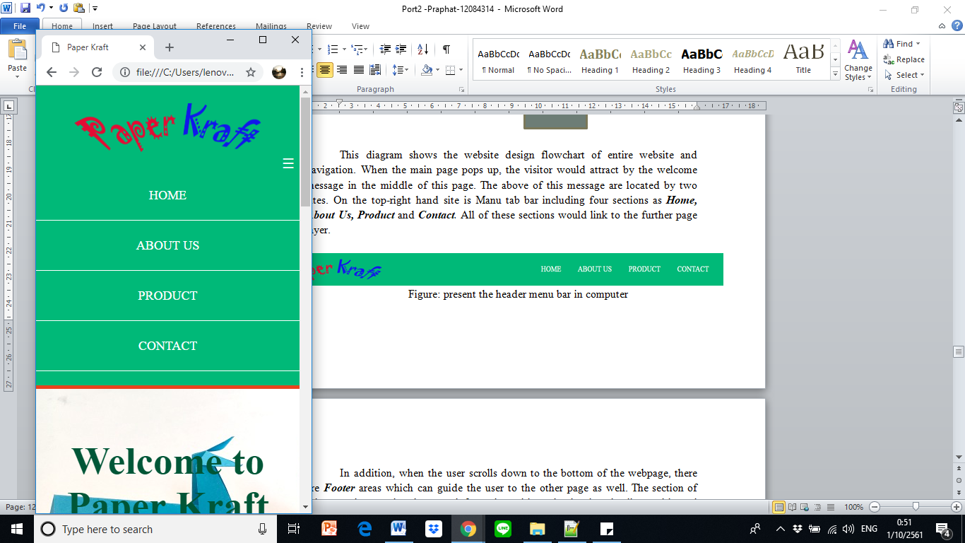

Figure 7: navigation bar display on desktop and mobile device

Likewise, when the user scrolls down to the bottom of the webpage, the ***Footer*** areas would display the copyright and also contains the sitemap navigation bar which can guide the user to the other page properly.



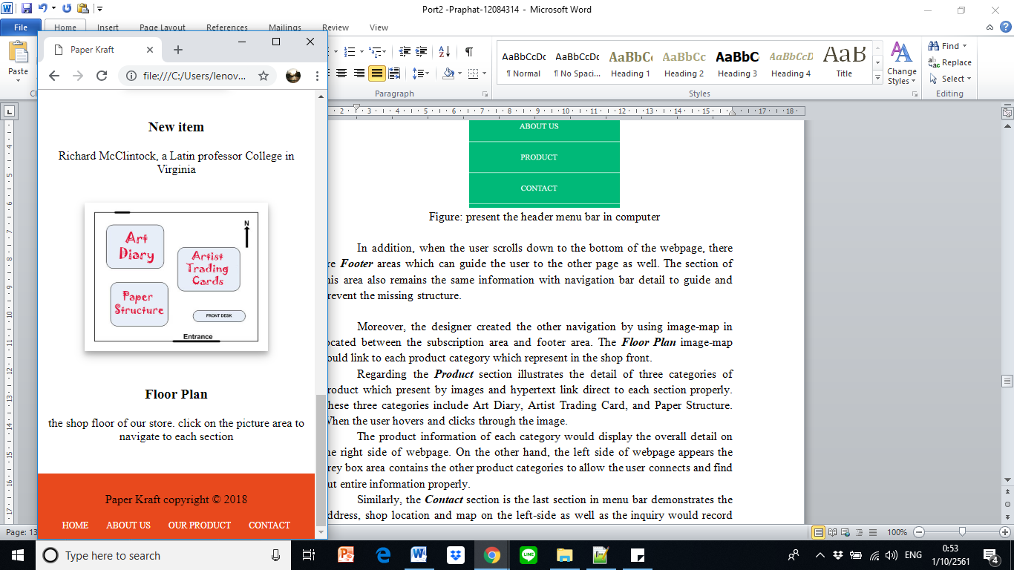

Figure 8: footer area display the navigation on desktop and mobile device

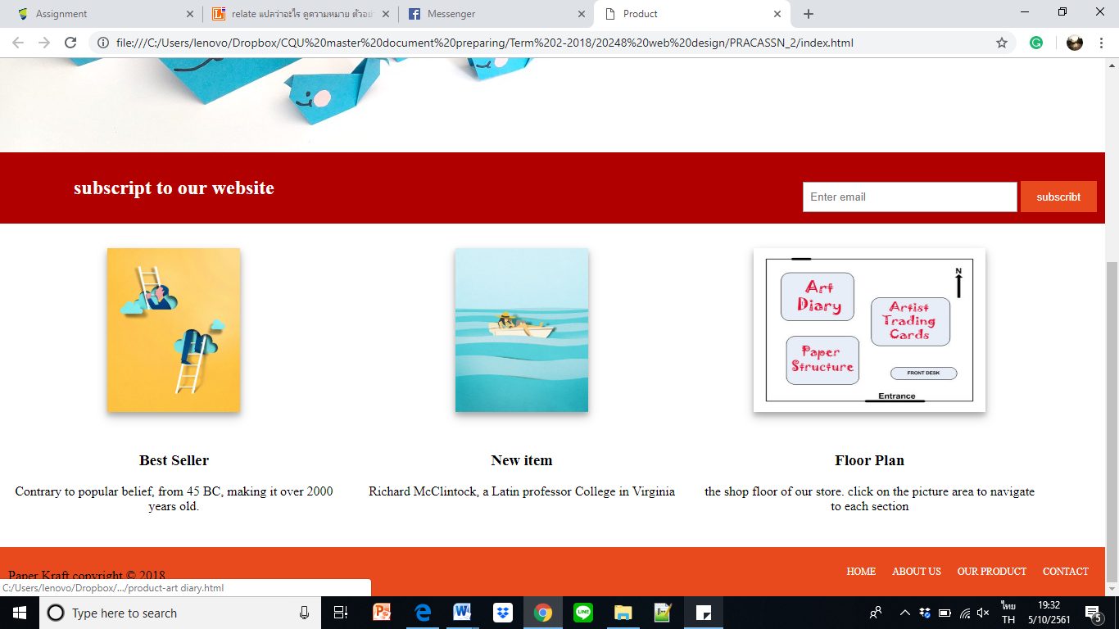

Figure 9: navigation by using image-map area

Besides, the *floor plan* image-map is one of the navigation. It contains three types of product’s list section as Art Diary, Artist Trading Card, and Paper Structure which allows the user can connect when hovers over image.

**Portfolio 2.4**

**CHAPTER 10: Data Tables**

Table is a two dimensional ordering data that presents in the cell. Its design could allow the user can read and easy to understand a massive data that the website would like to share

In HTML and CSS, there are key code that use to mention if creating a table as

* Captions: “*caption”*
* Row and column headings: *“th”*
* Columns and column groups: *“col and colgroup”*
* Rows and cells: *“tr and td”*

<tr>

<th> Operating day</th>

<th>Business time </th>

</tr>

<tr>

<td>Monday to Friday</td>

<td>8 am - 7pm </td>

</tr>

<caption>

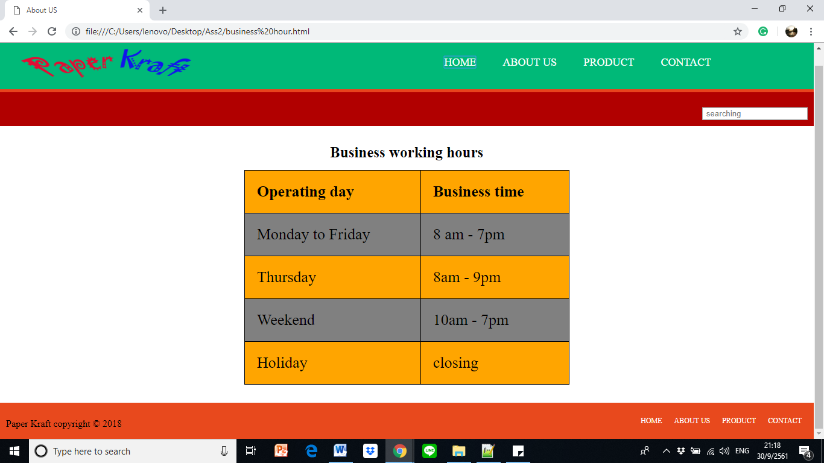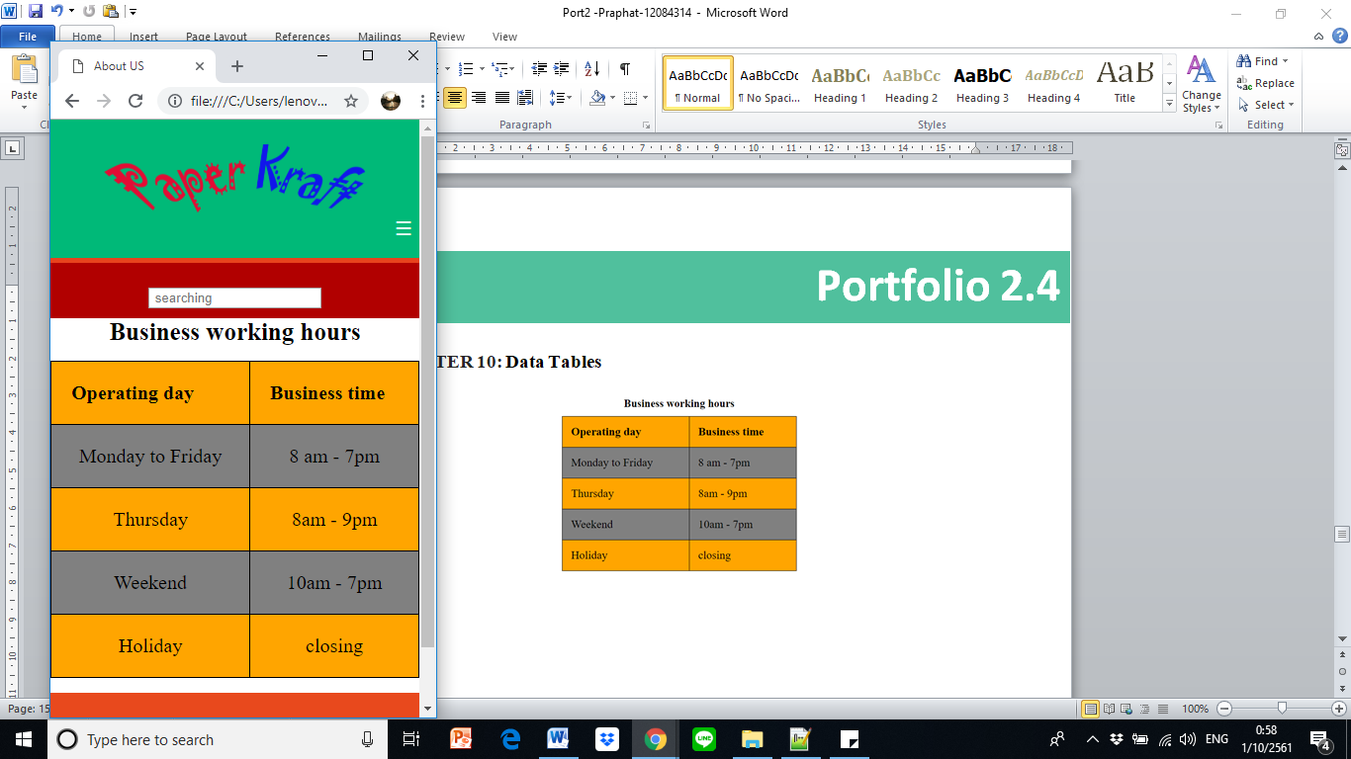

tr:nth-child(odd) {background-color: orange;}

tr:nth-child(even) {background-color: grey;

}

Figure 10: present the table design and code in business working hour webpage

**Portfolio 2.5**

**CHAPTER 11: Web Forms**

The web form is fields that allow the visitor enter the data then process through server. In this website, the designer was creating a form in Contact site to gather the visitor’s information as Name, Age, Gender, Country of origin, Personal interest and comment area.

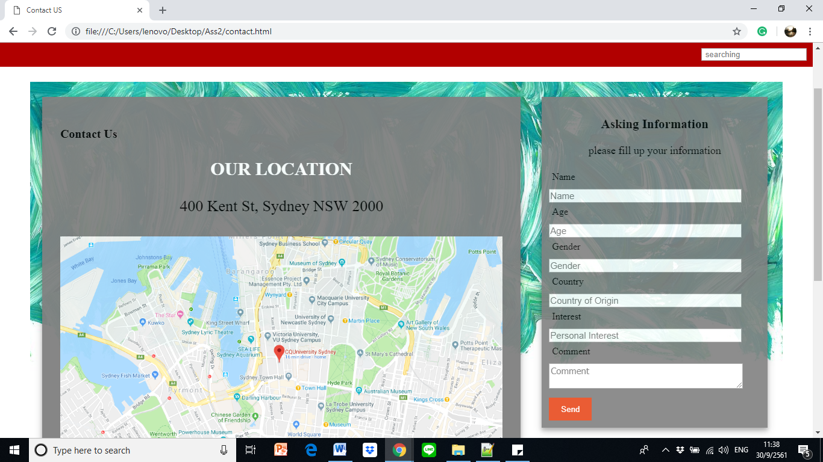

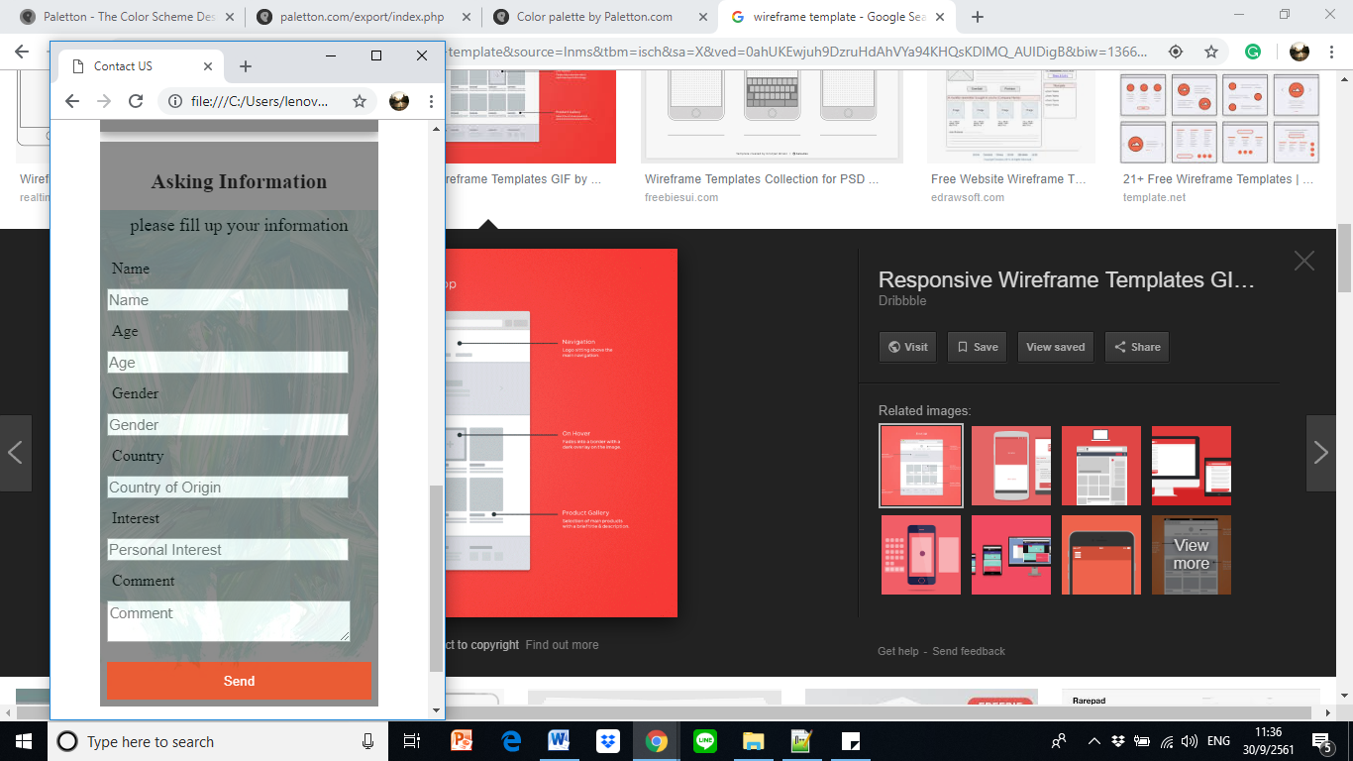

<textarea placeholder="Comment"></textarea>

<form class="quote">

</form>

<label>Name</label>

<input type="text" placeholder="Name">

Figure 11: present the particular code for form section

**Portfolio 2.6**

**CHAPTER 12: Responsive Web Design**

1. Testing the finished design in multiple browser and devices (simulators)

The website was tested with various browse for example Microsoft Edge, Chrome and Internet Explorer to ensure its competency.

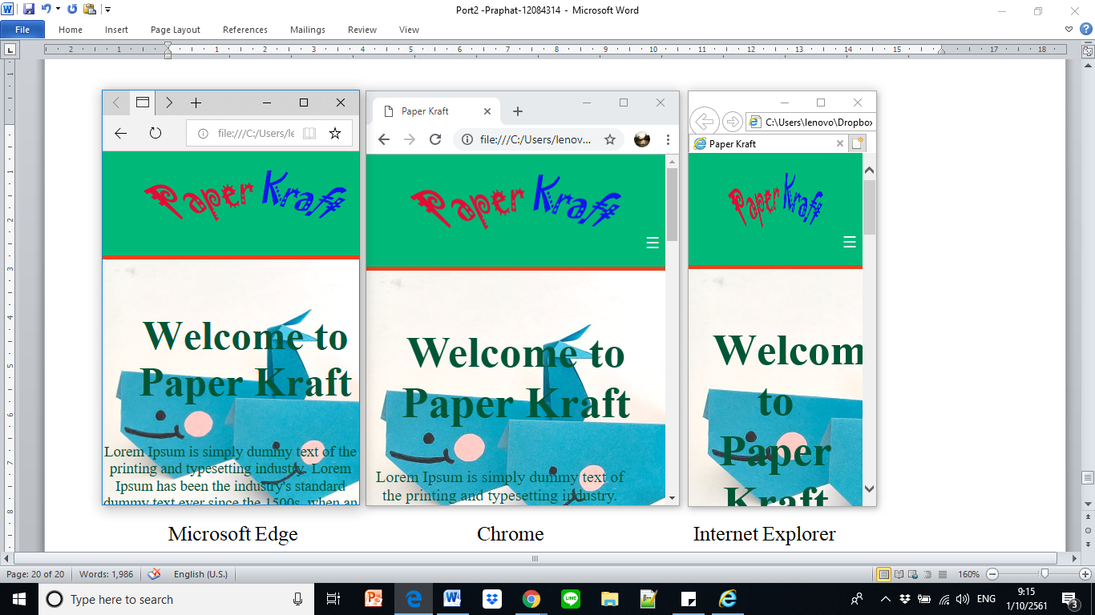

Figure 12: three browsers comparing with minimum width and same height by computer.

When comparing three of these browsers with the minimum width and same height, they appeared with different display and also some expected details were changed in desktop size as follow,

|  |  |  |  |
| --- | --- | --- | --- |
|  | Microsoft Edge | Chrome | Internet Explorer |
| Header area | The background shrank with unbalancing white space on the left site. | Represent as an idea framwork | The logo squeezed with missing white space area in the left site |
| Hamburger icon | Disappeared when the collapse to minimum width. However it will display when increase the width slightly. | Appeared | Appeared |
| Message area | Most of the information in the paragraph were shown | Partial of information in the paragraph were shown | Only heading topic was shown without the paragraph. |
| Image map navigation | Showed the image without the hypertext link to connect | Showed the image and hyperlink when hover. | Showed image with squeezed size and without the hypertext link |

However, those of browsers present the entire major feature and connect to each page properly without any issue. In addition, it appeared only minor issue about the graphic arrangement according to browser’s limitation.

In addition, this website was tested with Google device simulator in various screen size such as Iphone 7, Nexus 10 and Ipad Pro both landscape and portrait view as following.

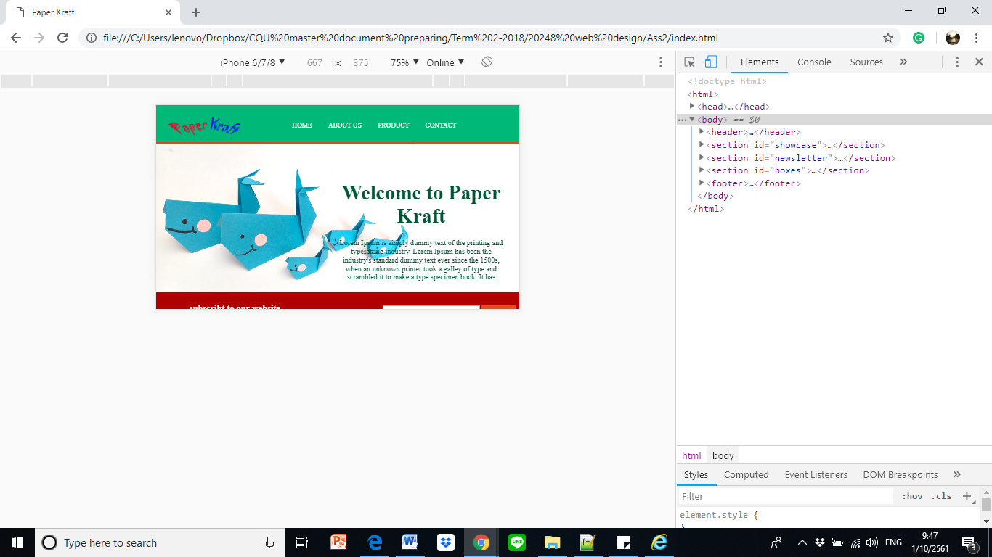 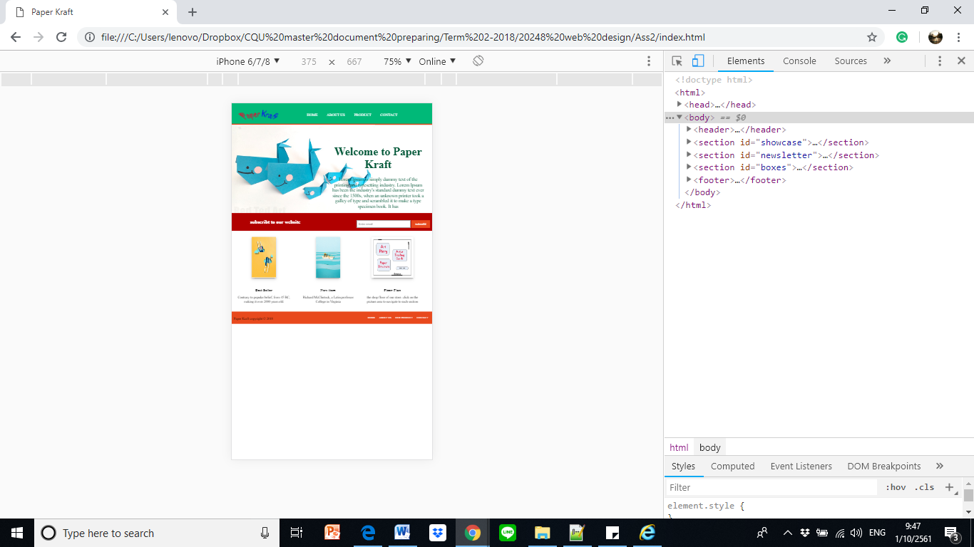

Figure 13: landscape and portrait scree by Iphone 7 size: 667x375px

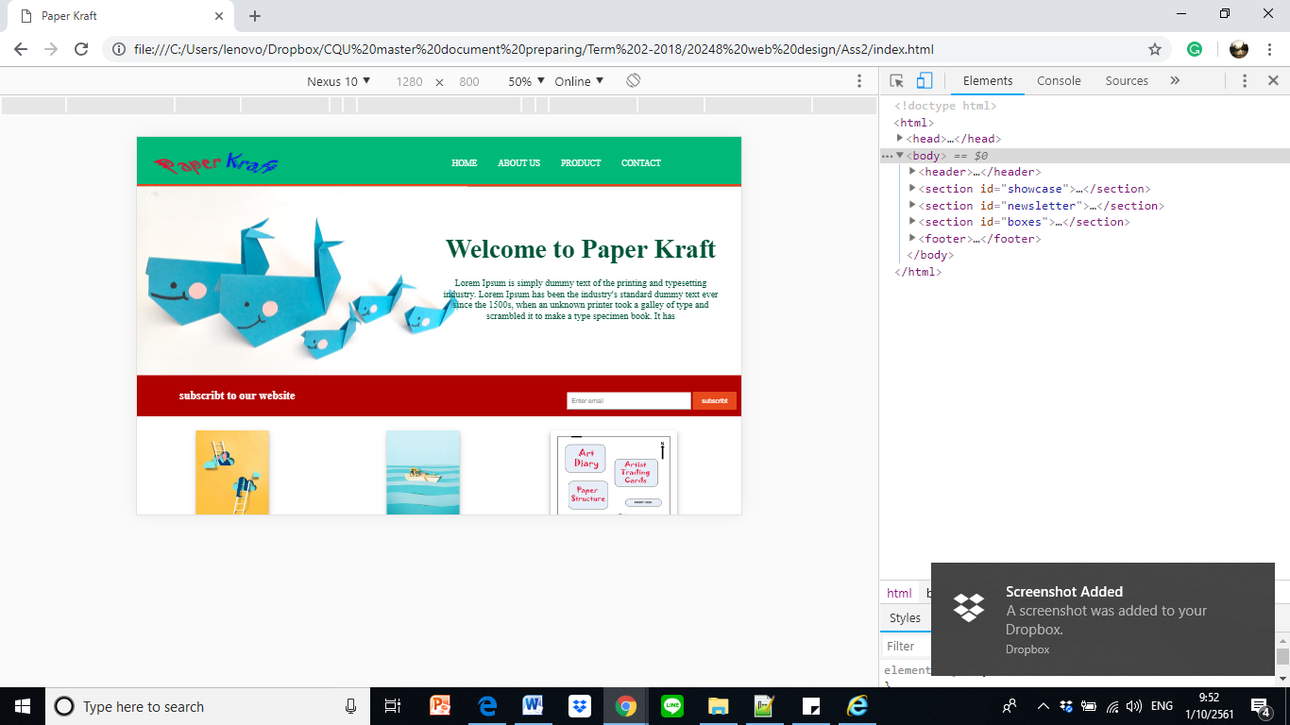 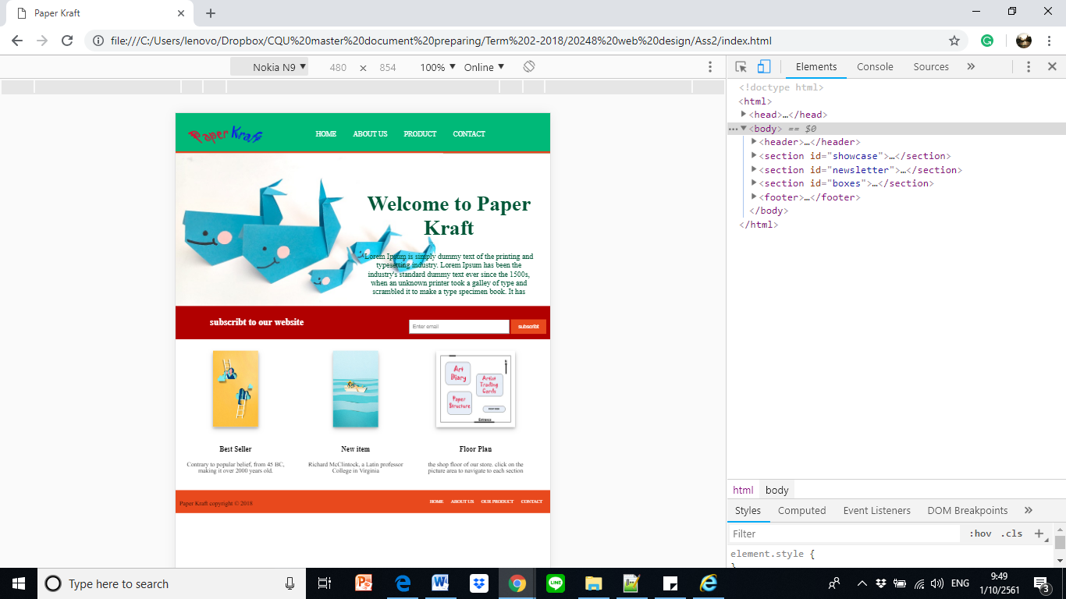

Figure 14: landscape and portrait scree by Nexus 10 size: 800x1280px

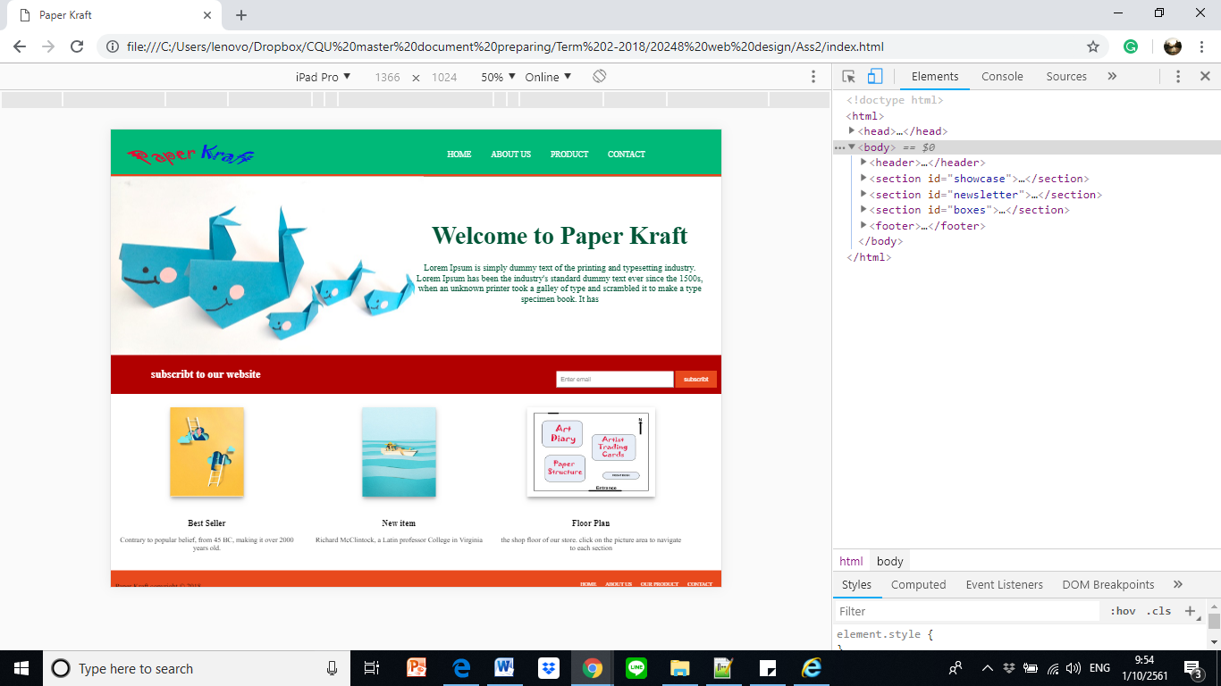 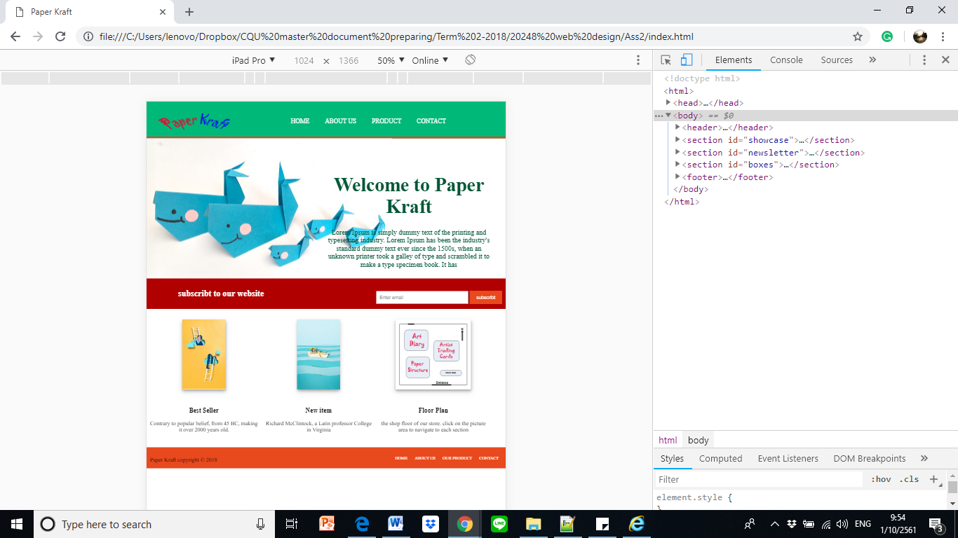

Figure 15: landscape and portrait scree by Ipad Pro size: 1024x1366px

Eventually, this website design was tested and reviewed by three profession and mention as below.

**Name: Khalid Jaoune**

**Gender: Male**

**Profession: Architect**

He mentions that the website is legitimate with contrast color and there are a couple main colors as green and red color. In addition, he likes the first page that contains the background images. It is easy to use and link to each other page. He also recommends having more professional in term of animation picture and gallery that may attract the user. In contrast, when he switched to small screen size, he also recommended having better white space management because the design was slightly change.

**Name: Naomi Suke**

**Gender: Female**

**Profession: Diploma student**

She tested with the small device and explained about her opinion as; she liked the overall design and toggle (hamburger icon) which allowed her to link to other page easily. But she suggests to add on the sub-menu for product category into the toggle site with might be linked directly instead of scrolling down to the bottom. In addition, she would prefer to have some more information and/or other external link which can connect to other website, for example, the link that connect to artist’s profile which allowed her to know more background or other website that can encourage the products.

**Name: Lalita Tong**

**Gender: Female**

**Profession: Online seller**

According to her opinion, she liked the entire images that display in the website as well as easy to read and understand. She can realize the navigation bar both of the header and footer area that made her connect to other page correctly. Likewise, the form area was clear and easy to fill up her information, and the working hour operation in the table was obvious seen. However, she would recommend adding on some features such as the animated gallery section and scrolling-up icon that might convenience when she would like to back to the top of webpage. In addition, she would like the designer to create a reality map in location area by interacting with Google Maps instead of the map image in Contact section. She said it might be convenient to her when she plan to the shop, she could estimate the distance, timing and transportation from her area directly.

As the result, these participants satisfied the entire website design in term of the graphic image and color which easy to understand and communicate the brand and product information properly, the font-color, size, and style were design for legitimate. In addition, the responsive website design worked smoothly and presented with main features properly, hypertext link connected to other page correctly, table and form performed well with the right information.

On the other hand, there were some comments from the reviewers to improve, for instance, the sub-menu for product list in toggle area, white space area when switching between small devices and desktop screen, as well as the displaying image would be enlarge and/or present in terms of animate gallery that would attract the user to stay longer time. Likewise, these entire comments would be beneficial to adjust for better website also.

According the participant’s comments lead the designer to have assumption for further development about the web as.

1. Having the product category (sub-menu) under the product section in menu bar would encourage the user to access the product information easily.
2. Having a real-time location map as connecting to Google Maps to encourage the customer go to the shop and choose the transportation venue properly.
3. Having banner and external webpage, for instance, artist’s profile and other’s community webpage might allow the user to connect and know related information.
4. Having image gallery to present the product items as well as the animated picture would attract to visitor and spend longer time in website.

**Portfolio 2: Summary**

Refer to the Paper Kraft’s requirement, this report explains and applied the responsive design into the developed website which contained four sections of navigation as Home, About Us, Product and Contact.

Regarding the portfolio 2.1 explained the entire webpages both of desktop screen resolution and mobile device. The wireframe of this section demonstrated the responsive idea and location of each element both of landscape and portrait view. In addition, this website adapted the toggle (hamburger icon) into the small screen of device which encourages the user to find out and guide to other page properly.

Likewise, the graphics and color design were accommodating to this website by applying the contrast color such as the Green color as a primary, Red and Blue color as a secondary color. On the other hand, the font color is one of the crucial factors that encourage having effective legitimation. The two background-images were implemented in this portfolio, first image was in the homepage site and other image was applied to the rest of website.

The flowchart of this website was illustrated in portfolio 2.3 that mentioned the entire navigation website regarding the diagram to understand the structure properly. This part also mentions the menu bar both of header area and footer area to connect to other page when hover on them.

Last section of this repost delivered the testing result and explained how the website presented when using different browser. As well as, this section interviewed three users and collected the feedback to improve further. The finding mentioned that the participants satisfied with the responsive website design in term of graphic, color, font, ease to use and clear message on website as well as the way of navigation flowchart both of desktop and small devices. However, there were some suggestions about creating sub-menu and animated image gallery to make the vital website and more attractive to user.

**Reference**

# Barker, S 2016, *The psychology of color in web design,* viewed 30 September 2018,

<https://www.vandelaydesign.com/the-psychology-of-color-in-web-design/>